**Explore Apache Spark on Microsoft Azure**

Completed100 XP

* 3 minutes

Apache Spark is a distributed processing framework for large scale data analytics. You can use Spark on Microsoft Azure in the following services:

* Azure Synapse Analytics
* Azure Databricks
* Azure HDInsight

Spark can be used to run code (usually written in Python, Scala, or Java) in parallel across multiple cluster nodes, enabling it to process very large volumes of data efficiently. Spark can be used for both batch processing and stream processing.

**Spark Structured Streaming**

To process streaming data on Spark, you can use the *Spark Structured Streaming* library, which provides an application programming interface (API) for ingesting, processing, and outputting results from perpetual streams of data.

Spark Structured Streaming is built on a ubiquitous structure in Spark called a *dataframe*, which encapsulates a table of data. You use the Spark Structured Streaming API to read data from a real-time data source, such as a Kafka hub, a file store, or a network port, into a "boundless" dataframe that is continually populated with new data from the stream. You then define a query on the dataframe that selects, projects, or aggregates the data - often in temporal windows. The results of the query generate another dataframe, which can be persisted for analysis or further processing.

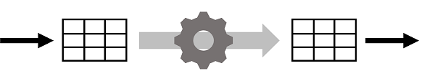

Spark Structured Streaming is a great choice for real-time analytics when you need to incorporate streaming data into a Spark based data lake or analytical data store.

**Note**

For more information about Spark Structured Streaming, see the [**Spark Structured Streaming programming guide.**](https://spark.apache.org/docs/latest/structured-streaming-programming-guide.html)

**Delta Lake**

Delta Lake is an open-source storage layer that adds support for transactional consistency, schema enforcement, and other common data warehousing features to data lake storage. It also unifies storage for streaming and batch data, and can be used in Spark to define relational tables for both batch and stream processing. When used for stream processing, a Delta Lake table can be used as a streaming source for queries against real-time data, or as a sink to which a stream of data is written.

The Spark runtimes in Azure Synapse Analytics and Azure Databricks include support for Delta Lake.

Delta Lake combined with Spark Structured Streaming is a good solution when you need to abstract batch and stream processed data in a data lake behind a relational schema for SQL-based querying and analysis.